**IC TRAINING CENTER VIET NAM**

**FUNDAMENTAL IC DESIGN AND VERIFICATION COURSE**



**FINAL PROJECT**

**TIMER IP DESIGN SPECIFICATION**

**Student: Doan Le Nhan**

**Class: IC28**

**Instructor: Kha Kham**

Contents

1.Overview 4

1.1. Introduction 4

1.2. Main features 4

1.3. Design Proposal 9

1.3. Block diagram 12

1.4. Interface signals 22

2.Register Specification 26

2.1. Register Summary 26

2.2. Timer Control Register (TCR) 26

2.3. Timer Data Register 0 (TDR0) 27

2.4. Timer Data Register 1 (TDR1) 28

2.5. Timer Compare Register 0 (TCMP0) 28

2.6. Timer Compare Register 1 (TCMP1) 29

2.7. Timer Interrupt Enable Register (TIER) 29

2.8. Timer Interrupt Status Register (TISR) 30

2.9. Timer Halt Control Status Register (THCSR) 31

3. Functional Description 32

3.1. APB slave – Register - Counter 32

3.2. Counter Control 33

3.3. Interrupt 34

4. Sample Waveform 35

5. VPLAN 36

6. URL FILE CODE 38

RTL CODE 38

TESTCASE 38

7. RESULT 39

RESULT WITH TESTBENCH + TESTCASES 39

RESULT WITH GOLDEN MODEL 40

COVERAGE 41

# 1.Overview

## 1.1. Introduction

The Timer Counter IP (timer_top) is a configurable 64-bit timer supporting normal counting, divided counting, compare-match interrupt generation, and debug-halt.  
Software controls the timer through APB registers, while the hardware provides stable timing and interrupt capability.

**Applications include:**  
• Periodic timer events  
• Timeout detection  
• Event scheduling  
• Real-time counters  
• Heartbeat generation  
• Low-frequency divided counters  
• Debug halt support

## 1.2. Main features

The Timer Counter IP provides the following key features:

**General**

* 64-bit up-counter with continuous increment behavior.
* APB slave interface with 32-bit data width with byte-write support (pstrb[3:0]) and one wait states.

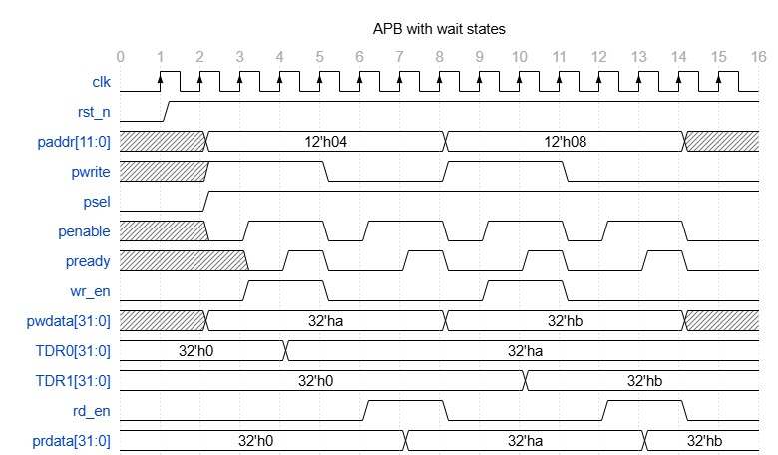

Fig 1. APB with wait states

**Counting Modes**

* **Normal mode:**  
  Counter increments every system clock cycle when TCR.timer_en = 1.
* **Divider mode:**  
  When TCR.div_en = 1, the counter increments at a reduced rate determined by TCR.div_val  
  (divide-by 1, 2, 4, 8, …, 256).
* Some example waveform of counter if control mode:

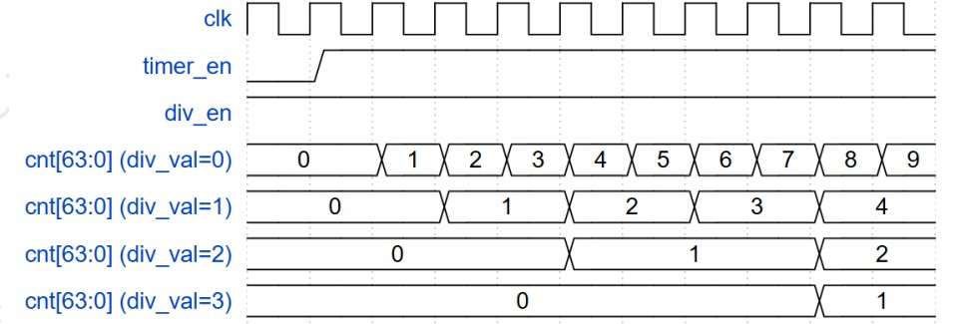

Fig 2. Counter control mode with different div_val

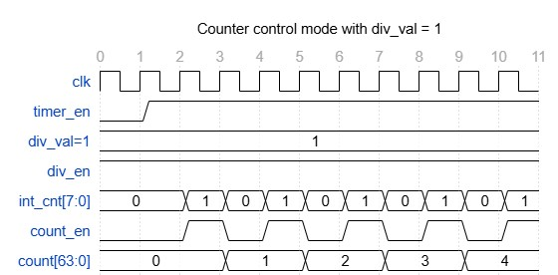

Fig 3. Counter control mode with div_val = 1

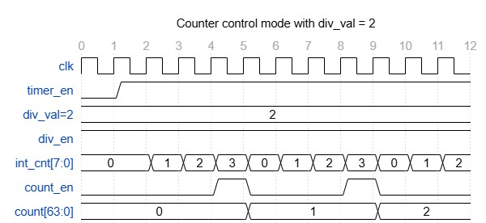

Fig 4. Counter control mode with div_val = 2

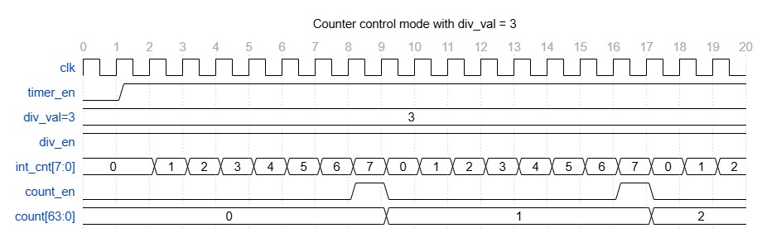

Fig 5. Counter control mode with div_val = 3

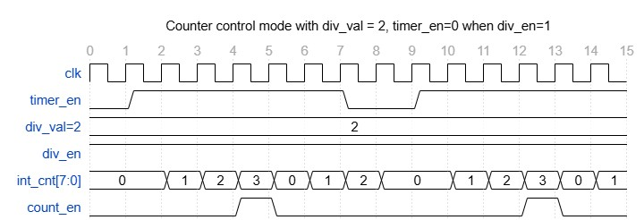

Fig 6. Counter control mode with div_val = 2, timer_en=0 when div_en=1

* **Halt mode (debug freeze):**  
  Counter halts only when both dbg_mode = 1 and THCSR.halt_req = 1.  
  The counter resumes once halt_req is cleared.

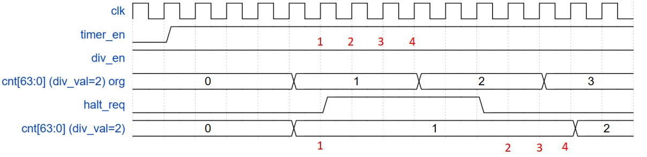

Fig 7. Counter is halted

* **Protection rules:**  
  Divider settings (div_en, div_val) cannot be modified while timer is running.  
  Invalid divider values (div_val > 8) produce an error response.

***Counter Behavior***

* *Counter reloads from TDR0/TDR1 when timer is enabled.*
* *Counter clears to zero when timer_en transitions from 1 → 0.*

**APB Interface Behavior**

* One-cycle wait state inserted automatically (pready = wr_en | rd_en).
* Illegal writes generate APB error (pslverr = 1).
* On error, the write is ignored and the register retains its previous value.
* Supports byte access for partial register update.

**Interrupt System**

* Interrupt asserted when the counter matches the 64-bit compare value {TCMP1, TCMP0}.
* Interrupt enable via TIER.int_en.
* Interrupt status (TISR.int_st) uses RW1C behavior (write-1-to-clear).
* Disabling int_en masks the output interrupt but preserves the pending flag.

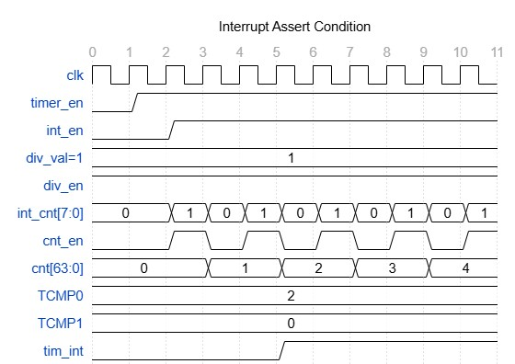

Fig 8. Interrupt assert condition

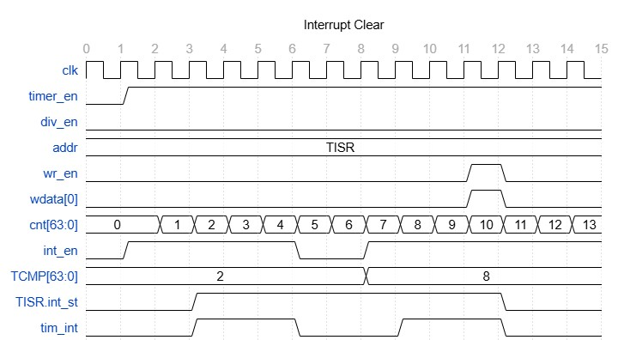

Fig 9. Interrupt clear

## 1.3. Design Proposal

The Timer IP provides the following features:

**APB Slave Interface Behavior**

• 32-bit APB slave  
• Byte-write via pstrb  
• Always inserts 1 wait state (pready = wr_en | rd_en)  
• Error detection (pslverr = 1 when):  
 – Writing invalid div_val > 8  
 – Modifying div_val / div_en while timer_en = 1  
• On error → write ignored, registers keep old value

**64-bit Counter (CNT64) with Divider Mode**

• Up-counter stored in TDR0 (low 32 bits) and TDR1 (high 32 bits)  
• Increments when timer_en = 1  
• Normal mode: increment every clock  
• Divider mode: increment every **2^div_val** cycles  
• Overflow wraps to 0  
• timer_en: 1→0 → counter cleared  
• timer_en: 0→1 → counter reloads from TDR0/TDR1 *Divider Mode (div_en & div_val)* when timer_en = 1 & div_en = 1:

Table 1. Divider Mode of Counter

| div_val | Divide Factor |
| --- | --- |
| 4'b0000 | 1 (no division) |
| 4'b0001 | 2 |
| 4'b0010 | 4 |
| 4'b0011 | 8 |
| 4'b0100 | 16 |
| 4'b0101 | 32 |
| 4'b0110 | 64 |
| 4'b0111 | 128 |
| 4'b1000 | 256 |

Reserved values (>8) → PSLVERR.

***Protection:*** *• div_en and div_val cannot change while running (timer_en=1)  
• Illegal writes → PSLVERR + write ignored*

**Interrupt Mechanism**

*• int_en – interrupt enable  
• int_st – compare-match status  
• tim_int – final output interrupt*

***Trigger:*** *• cnt_64b == cmp_64b → int_st = 1  
• If int_en = 1 → tim_int = 1*

***Clear:*** *• RW1C: write 1 → clear int_st  
• Writing 0 → ignored  
• Clearing int_en masks tim_int*

**Debug Halt**

Halt occurs only if:

1. dbg_mode = 1
2. halt_req = 1

While halted:  
• Counter frozen  
• halt_ack = 1

When halted released:  
• halt_ack = 0  
• Counter resumes exactly

If dbg_mode = 0:  
• halt_req ignored  
• No halting

## 1.3. Block diagram

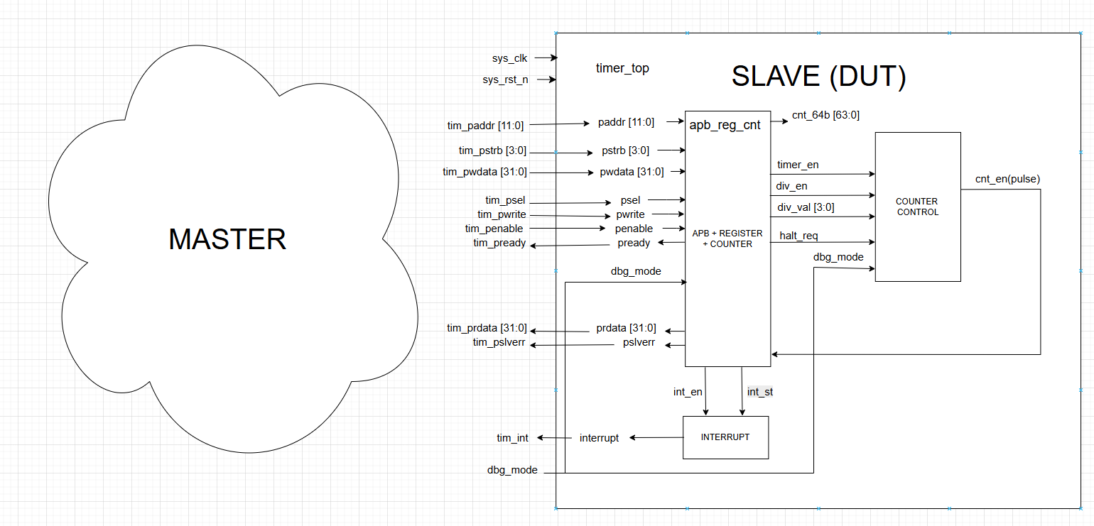

Fig 10. Block diagram of the DUT

*• APB Interface/ Register/Counter Block: APB interface and TCR, TDR0/1, TCMP0/1, TIER, TISR, THCSR, 64-bit counter.  
• Counter Control Block: generates cnt_en based on dividers & halt logic  
• Interrupt Block*

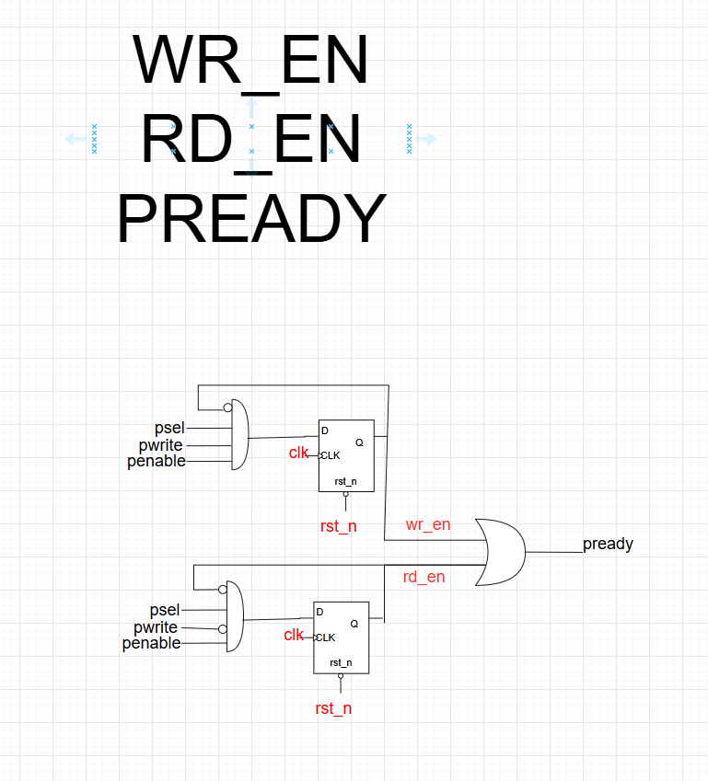Fig 11. Write/Read Logic and PREADY Logic

*• wr_en and rd_en generated from psel/penable/pwrite  
• 1-cycle pulse for deterministic register access*

*• pready = wr_en | rd_en*

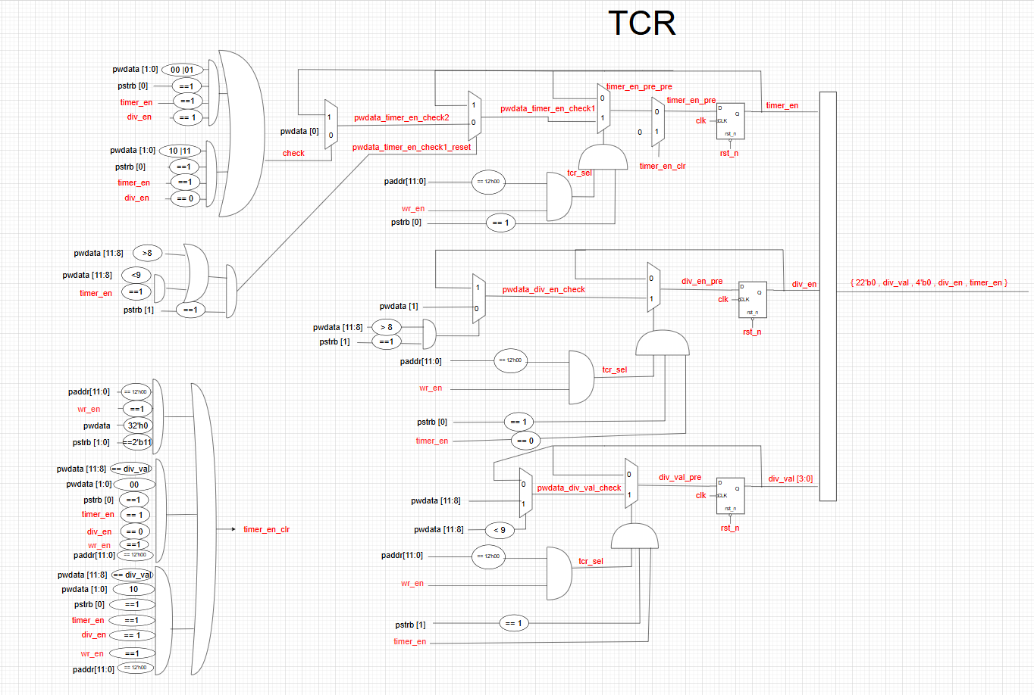

Fig 12. – Timer Control Register (TCR) Logic

*• Handles timer_en, div_en, div_val  
• Protects divider values when running  
• Invalid writes flagged by PSLVERR*

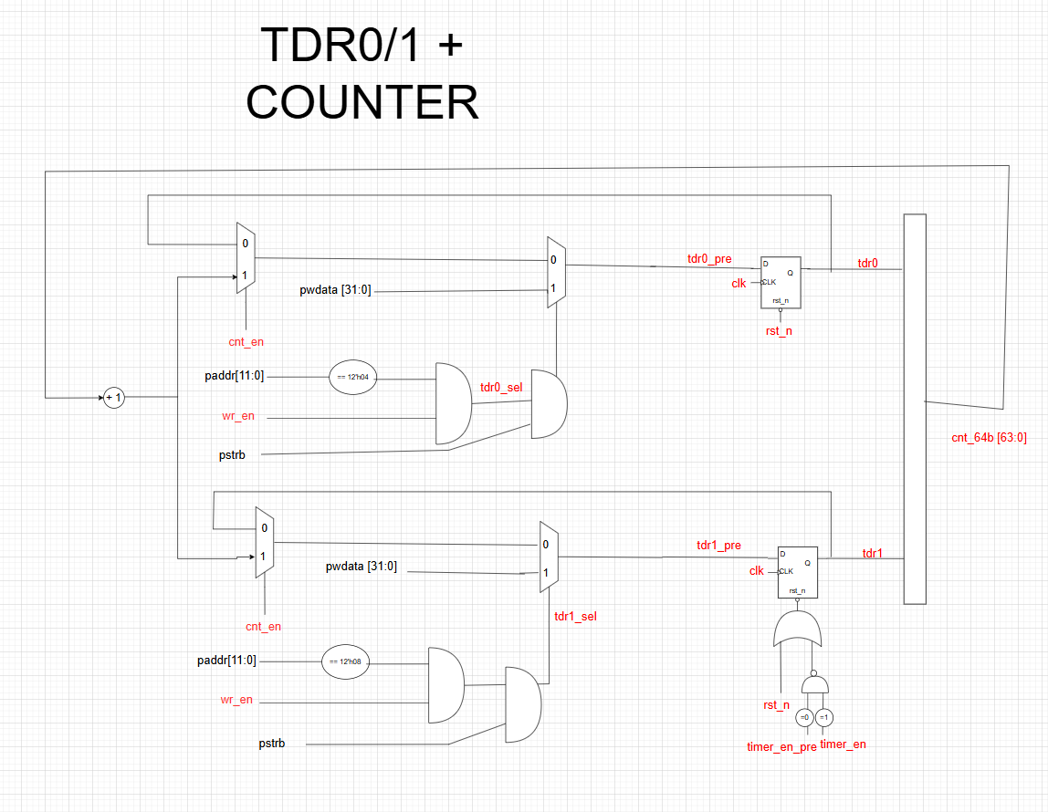

Fig 13. TDR0/TDR1 and 64-bit Counter

*• TDRs mirror CNT64 for readback  
• Counter reload on timer_en   
• Counter reset on timer_en high to low*

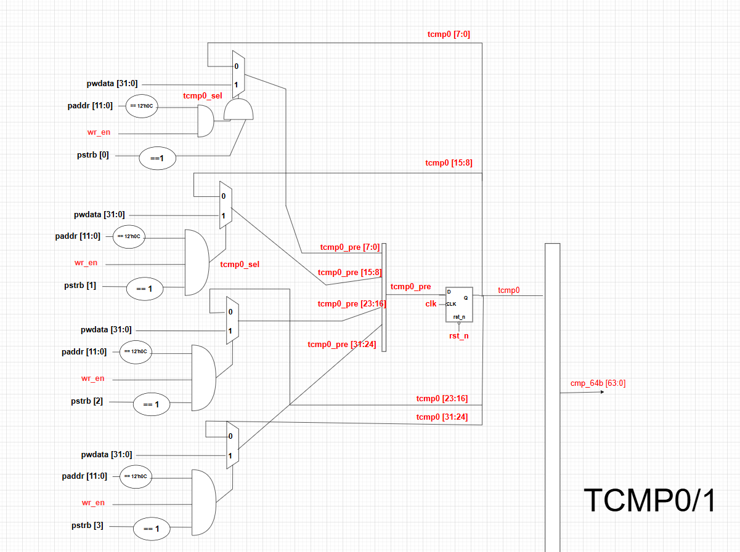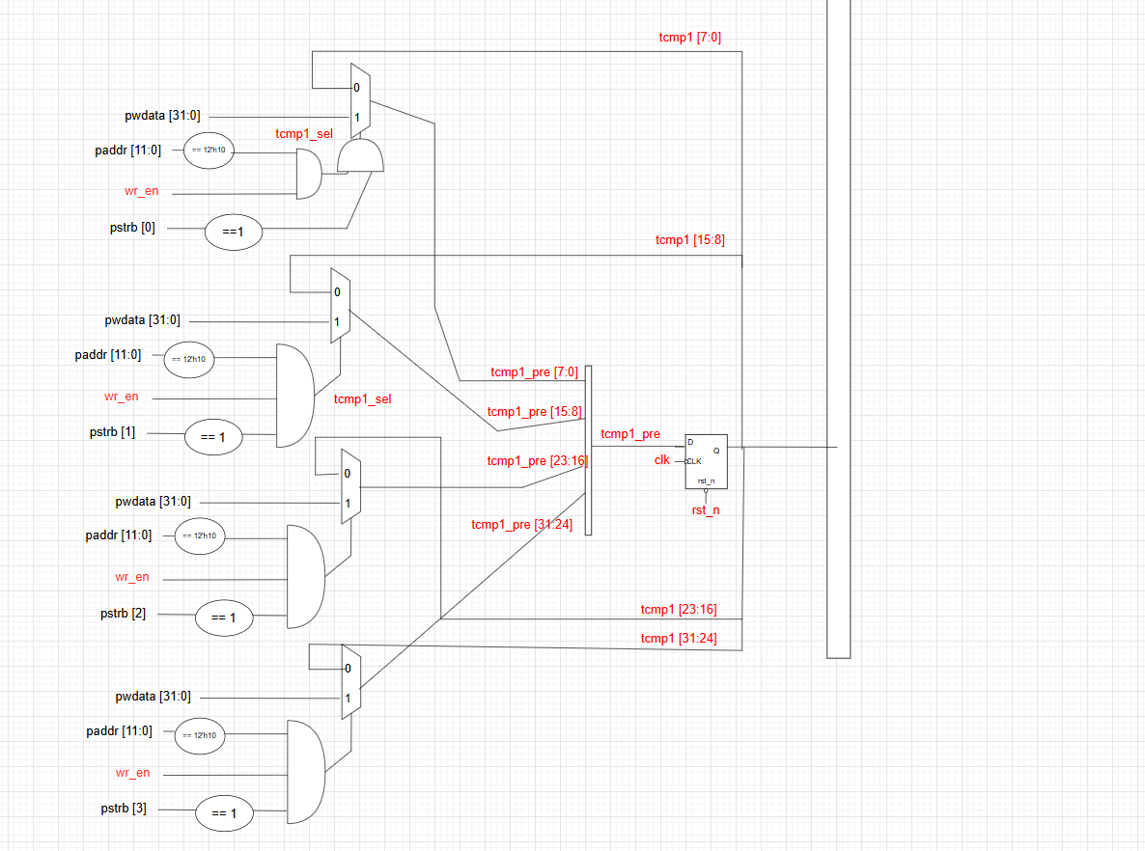

Fig 14. Compare Registers (TCMP0/TCMP1)

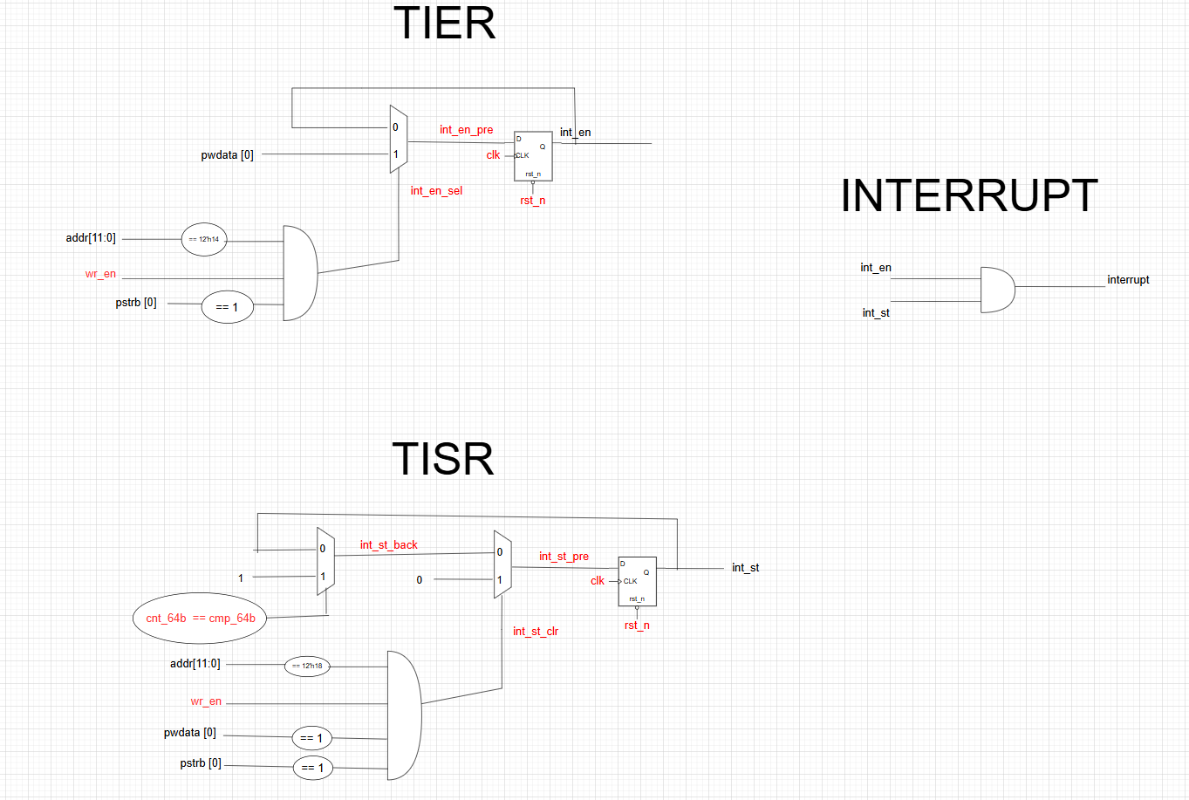

Fig 15. Interrupt Logic (TIER, TISR in Register) & Interrupt Block

*• Compare-match sets int_st and the tim.int will assert if the int_en is turn on too  
• RW1C clear TISR  
• tim_int = int_en & int_st*

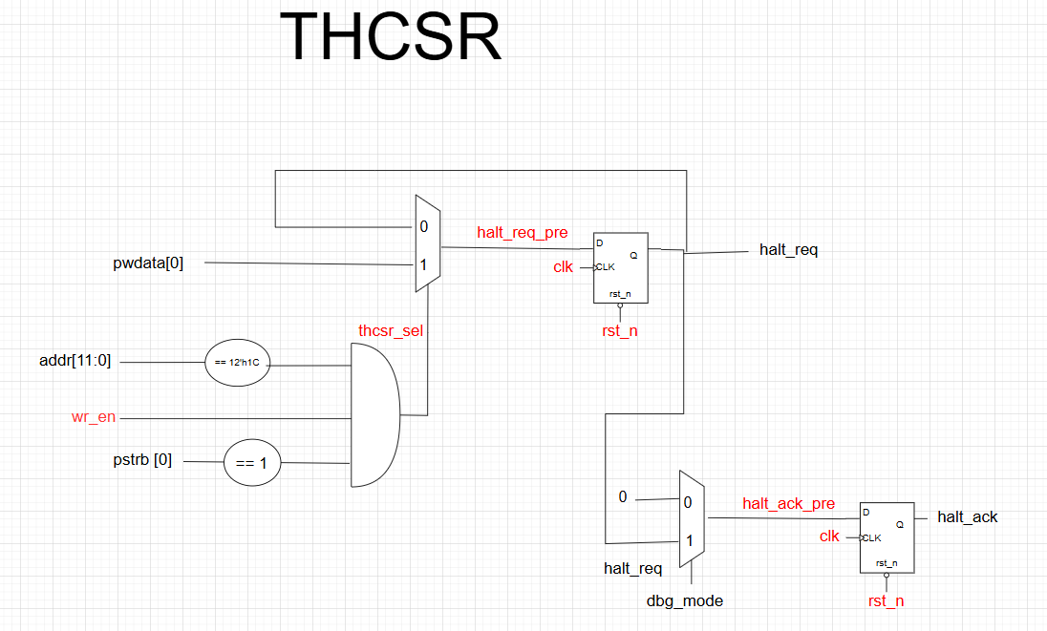

Fig 16. Halt Control Register (THCSR)

*• Works only when dbg_mode = 1  
• Freeze counter + assert halt_ack*

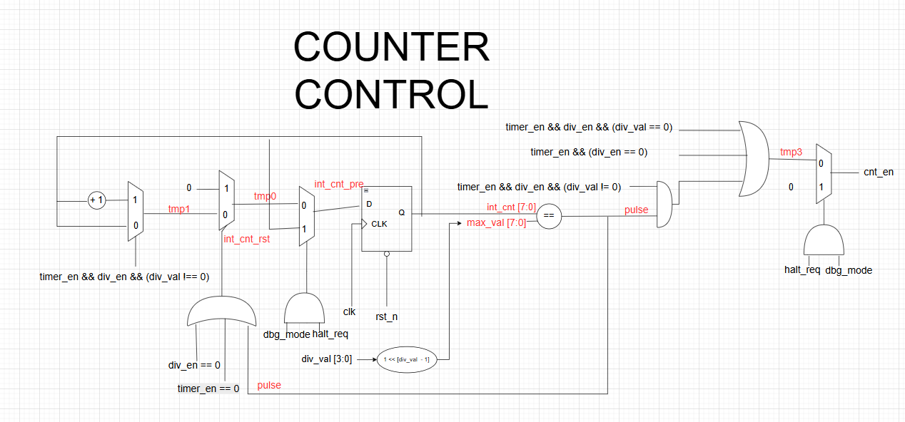

Fig 17. Counter Control Module

*• Generates cnt_en  
• Normal mode or divided mode  
• Prescaler resets when timer disabled*

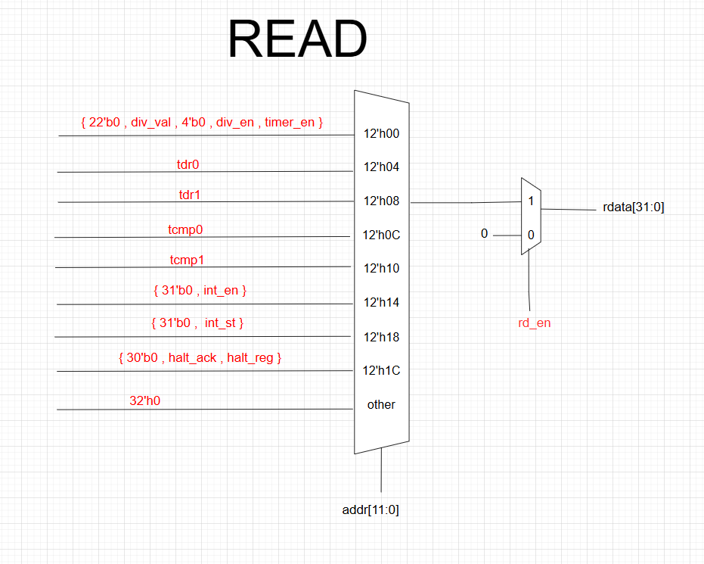

Fig 18. Register Read Path

*• rd_en selects register for PRDATA*

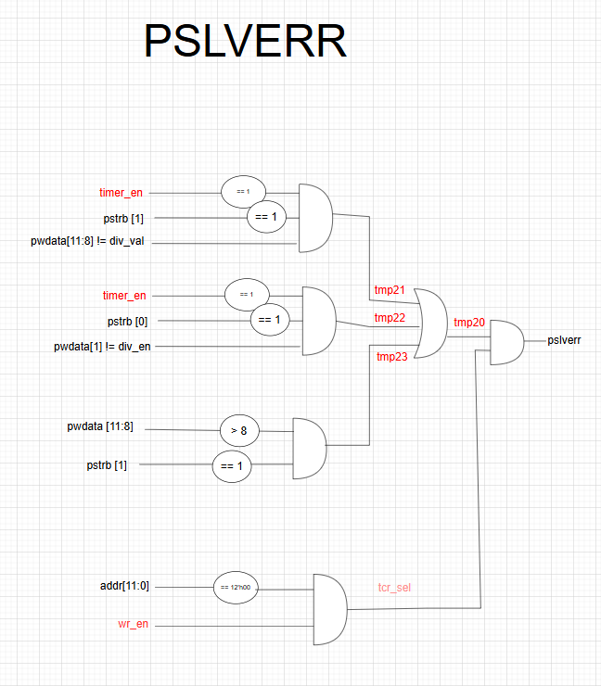

Fig 19. PSLVERR Logic

*• Illegal divider writes → PSLVERR*

## 1.4. Interface signals

Table 2. Interface signals of timer IP

| Signal name | Width | Direction | Description |
| --- | --- | --- | --- |
| sys_clk | 1 | Input | System clock for the entire timer module. All internal logic operates on this clock. |
| sys_rst_n | 1 | Input | Active–low system reset. Resets all registers and internal states. |
| tim_psel | 1 | Input | APB select signal. Indicates valid APB transfer is requested. |
| tim_pwrite | 1 | Input | APB write control (1 = write, 0 = read). |
| tim_penable | 1 | Input | APB enable phase indicator. |
| tim_paddr[11:0] | 12 | Input | APB address bus selecting timer registers. |
| tim_pwdata[31:0] | 32 | Input | APB write data bus. |
| tim_prdata[31:0] | 32 | Output | APB read data bus returning data from selected register. |
| tim_pstrb[3:0] | 4 | Input | Byte strobe for partial write. Controls which bytes of the register are updated. |
| tim_pready | 1 | Output | APB ready signal. Indicates transfer completion. |
| tim_pslverr | 1 | Output | APB error response. Asserted when illegal register write occurs. |
| tim_int | 1 | Output | Timer interrupt output. Active when compare match occurs AND interrupt enabled. |
| dbg_mode | 1 | Input | Debug mode indicator. Enables halt mechanism. Should not change while timer_en = 1 during operation. |

Table 3. Interface signals of APB Register Counter

| **Signal name** | **Width** | **Direction** | **Description** |
| --- | --- | --- | --- |
| clk | 1 | Input | System clock. |
| rst_n | 1 | Input | Active-low reset. |
| paddr | 12 | Input | APB address bus. |
| pstrb | 4 | Input | Write byte-strobe for partial update. |
| pwdata | 32 | Input | APB write data. |
| psel | 1 | Input | APB select signal. |
| pwrite | 1 | Input | APB write control. |
| penable | 1 | Input | APB enable phase. |
| pready | 1 | Output | APB ready response. Indicates transfer completion. |
| prdata | 32 | Output | APB read data. |
| pslverr | 1 | Output | APB error response for illegal write. |
| cnt_en | 1 | Input | Count-enable pulse from counter controller. |
| timer_en | 1 | Output | Timer enable decoded from TCR. |
| div_en | 1 | Output | Divider enable decoded from TCR. |
| div_val | 4 | Output | Clock-divider ratio (TCR bits[11:8]). |
| halt_req | 1 | Output | Debug halt request (THCSR). |
| cnt_64b | 64 | Output | 64-bit timer counter value. |
| int_en | 1 | Output | Interrupt enable (TIER). |
| int_st | 1 | Output | Interrupt status flag (TISR). |
| dbg_mode | 1 | Input | Debug mode indicator. |

Table 4. Interface signals of counter control block

| **Signal name** | **Width** | **Direction** | **Description** |
| --- | --- | --- | --- |
| clk | 1 | Input | System clock. |
| rst_n | 1 | Input | Active-low reset. |
| halt_req | 1 | Input | Request to halt counter in debug mode. |
| timer_en | 1 | Input | Timer run control from TCR. |
| div_en | 1 | Input | Divider enable. |
| div_val | 4 | Input | Divider value (0–8). |
| dbg_mode | 1 | Input | Debug mode enable (halts counter when halt_req=1). |
| cnt_en | 1 | Output | 1-cycle pulse used to increment 64-bit counter. |

Table 5. Interface signals of interrupt block

| **Signal name** | **Width** | **Direction** | **Description** |
| --- | --- | --- | --- |
| int_en | 1 | Input | Interrupt enable bit. |
| int_st | 1 | Input | Interrupt status flag. |
| interrupt | 1 | Output | Final interrupt output (int_en AND int_st). |

# 2.Register Specification

## 2.1. Register Summary

Table 6. Register Summary

| **Address** | **Abbreviation** | **Register name** |
| --- | --- | --- |
| **0x00** | **TCR** | **Timer Control Register** |
| **0x04** | **TDR0** | **Timer Data Register 0 (lower 32 bits of counter)** |
| **0x08** | **TDR1** | **Timer Data Register 1 (upper 32 bits of counter)** |
| **0x0C** | **TCMP0** | **Timer Compare Register 0 (lower 32 bits)** |
| **0x10** | **TCMP1** | **Timer Compare Register 1 (upper 32 bits)** |
| **0x14** | **TIER** | **Timer Interrupt Enable Register** |
| **0x18** | **TISR** | **Timer Interrupt Status Register** |
| **0x1C** | **THCSR** | **Timer Halt Control Status Register** |
| **Others** | **—** | **Reserved (RAZ/WI)** |

## 2.2. Timer Control Register (TCR)

**Offset address**: 0x0

**Reset value:** 0x0000_0000

**Bit field**

|  |  |  |  |  |  |  |  |  |  |  |  |  |  |  |  |
| --- | --- | --- | --- | --- | --- | --- | --- | --- | --- | --- | --- | --- | --- | --- | --- |
| 31 | 30 | 29 | 28 | 27 | 26 | 25 | 24 | 23 | 22 | 21 | 20 | 19 | 18 | 17 | 16 |
| Reserved | | | | | | | | | | | | | | | |
|  |  |  |  |  |  |  |  |  |  |  |  |  |  |  |  |

|  |  |  |  |  |  |  |  |  |  |  |  |  |  |  |  |
| --- | --- | --- | --- | --- | --- | --- | --- | --- | --- | --- | --- | --- | --- | --- | --- |
| 15 | 14 | 13 | 12 | 11 | 10 | 9 | 8 | 7 | 6 | 5 | 4 | 3 | 2 | 1 | 0 |
| Reserved | | | | DIV_VAL[3:0] | | | | Reserved | | | | | | DIV_  EN | TIM_  EN |
|  |  |  |  | rw | | | |  |  |  |  |  |  | rw | rw |

Table 7. Timer Control Register (TCR)

| **Bit** | **Name** | **Type** | **Default** | **Description** |
| --- | --- | --- | --- | --- |
| 31:12 | Reserved | - | 0 | Reserved. |
| 11:8 | DIV_VAL[3:0] | RW | 4'b0001 | Counter division factor. 0000: /1, 0001: /2, … 1000: /256. Others prohibited. |
| 7:2 | Reserved | RO | 0 | Reserved. |
| 1 | DIV_EN | RW | 0 | 1: Enable divider mode. 0: Normal counting mode. |
| 0 | TIM_EN | RW | 0 | Timer enable. 1 = start counter. |

## 2.3. Timer Data Register 0 (TDR0)

**Offset:** 0x04  
**Reset value:** 0x0000_0000

**Bit field**

|  |  |  |  |  |  |  |  |  |  |  |  |  |  |  |  |
| --- | --- | --- | --- | --- | --- | --- | --- | --- | --- | --- | --- | --- | --- | --- | --- |
| 31 | 30 | 29 | 28 | 27 | 26 | 25 | 24 | 23 | 22 | 21 | 20 | 19 | 18 | 17 | 16 |
| cnt_64b[31:16] | | | | | | | | | | | | | | | |
|  |  |  |  |  |  |  |  |  |  |  |  |  |  |  |  |

|  |  |  |  |  |  |  |  |  |  |  |  |  |  |  |  |
| --- | --- | --- | --- | --- | --- | --- | --- | --- | --- | --- | --- | --- | --- | --- | --- |
| 15 | 14 | 13 | 12 | 11 | 10 | 09 | 08 | 07 | 06 | 05 | 04 | 03 | 02 | 01 | 00 |
| cnt_64b[15:0] | | | | | | | | | | | | | | | |
|  |  |  |  |  |  |  |  |  |  |  |  |  |  |  |  |

Table 8. Register TDR0

| **Bit** | **Name** | **Type** | **Default** | **Description** |
| --- | --- | --- | --- | --- |
| 31:0 | TDR0 | RW | 0 | Lower 32 bits of 64-bit counter. Cleared when TIM_EN goes 1→0 (advanced level). |

## 2.4. Timer Data Register 1 (TDR1)

**Offset:** 0x08  
**Reset value:** 0x0000_0000

**Bit field**

|  |  |  |  |  |  |  |  |  |  |  |  |  |  |  |  |
| --- | --- | --- | --- | --- | --- | --- | --- | --- | --- | --- | --- | --- | --- | --- | --- |
| 31 | 30 | 29 | 28 | 27 | 26 | 25 | 24 | 23 | 22 | 21 | 20 | 19 | 18 | 17 | 16 |
| cnt_64b[63:48] | | | | | | | | | | | | | | | |
|  |  |  |  |  |  |  |  |  |  |  |  |  |  |  |  |

|  |  |  |  |  |  |  |  |  |  |  |  |  |  |  |  |
| --- | --- | --- | --- | --- | --- | --- | --- | --- | --- | --- | --- | --- | --- | --- | --- |
| 15 | 14 | 13 | 12 | 11 | 10 | 09 | 08 | 07 | 06 | 05 | 04 | 03 | 02 | 01 | 00 |
| cnt_64b[47:32] | | | | | | | | | | | | | | | |
|  |  |  |  |  |  |  |  |  |  |  |  |  |  |  |  |

Table 9. Register TDR1

| **Bit** | **Name** | **Type** | **Default** | **Description** |
| --- | --- | --- | --- | --- |
| **31:0** | **TDR1** | **RW** | **0** | **Upper 32 bits of 64-bit counter. Cleared when TIM_EN goes 1→0 (advanced level).** |

## 2.5. Timer Compare Register 0 (TCMP0)

**Offset:** 0x0C  
**Reset value:** 0xFFFF_FFFF

**Bit field**

|  |  |  |  |  |  |  |  |  |  |  |  |  |  |  |  |
| --- | --- | --- | --- | --- | --- | --- | --- | --- | --- | --- | --- | --- | --- | --- | --- |
| 31 | 30 | 29 | 28 | 27 | 26 | 25 | 24 | 23 | 22 | 21 | 20 | 19 | 18 | 17 | 16 |
| cmp_64b[31:16] | | | | | | | | | | | | | | | |
|  |  |  |  |  |  |  |  |  |  |  |  |  |  |  |  |

|  |  |  |  |  |  |  |  |  |  |  |  |  |  |  |  |
| --- | --- | --- | --- | --- | --- | --- | --- | --- | --- | --- | --- | --- | --- | --- | --- |
| 15 | 14 | 13 | 12 | 11 | 10 | 09 | 08 | 07 | 06 | 05 | 04 | 03 | 02 | 01 | 00 |
| cmp_64b[15:0] | | | | | | | | | | | | | | | |
|  |  |  |  |  |  |  |  |  |  |  |  |  |  |  |  |

Table 10. Register TCMP0

| **Bit** | **Name** | **Type** | **Default** | **Description** |
| --- | --- | --- | --- | --- |
| **31:0** | **TCMP0** | **RW** | **0xFFFF_FFFF** | **Lower 32 bits of compare value. Interrupt pending when counter == TCMP.** |

## 2.6. Timer Compare Register 1 (TCMP1)

**Offset: 0x10  
Reset value: 0xFFFF_FFFF**

**Bit field**

|  |  |  |  |  |  |  |  |  |  |  |  |  |  |  |  |
| --- | --- | --- | --- | --- | --- | --- | --- | --- | --- | --- | --- | --- | --- | --- | --- |
| 31 | 30 | 29 | 28 | 27 | 26 | 25 | 24 | 23 | 22 | 21 | 20 | 19 | 18 | 17 | 16 |
| cmp_64b[63:48] | | | | | | | | | | | | | | | |
|  |  |  |  |  |  |  |  |  |  |  |  |  |  |  |  |

|  |  |  |  |  |  |  |  |  |  |  |  |  |  |  |  |
| --- | --- | --- | --- | --- | --- | --- | --- | --- | --- | --- | --- | --- | --- | --- | --- |
| 15 | 14 | 13 | 12 | 11 | 10 | 09 | 08 | 07 | 06 | 05 | 04 | 03 | 02 | 01 | 00 |
| cmp_64b[47:32] | | | | | | | | | | | | | | | |
|  |  |  |  |  |  |  |  |  |  |  |  |  |  |  |  |

Table 11. Register TCMP1

| **Bit** | **Name** | **Type** | **Default** | **Description** |
| --- | --- | --- | --- | --- |
| 31:0 | TCMP1 | RW | 0xFFFF_FFFF | Upper 32 bits of compare value. |

## 2.7. Timer Interrupt Enable Register (TIER)

**Offset:** 0x14  
**Reset value:** 0x0000_0000

|  |  |  |  |  |  |  |  |  |  |  |  |  |  |  |  |
| --- | --- | --- | --- | --- | --- | --- | --- | --- | --- | --- | --- | --- | --- | --- | --- |
| 31 | 30 | 29 | 28 | 27 | 26 | 25 | 24 | 23 | 22 | 21 | 20 | 19 | 18 | 17 | 16 |
| Reserved | | | | | | | | | | | | | | | |
|  |  |  |  |  |  |  |  |  |  |  |  |  |  |  |  |

|  |  |  |  |  |  |  |  |  |  |  |  |  |  |  |  |
| --- | --- | --- | --- | --- | --- | --- | --- | --- | --- | --- | --- | --- | --- | --- | --- |
| 15 | 14 | 13 | 12 | 11 | 10 | 9 | 8 | 7 | 6 | 5 | 4 | 3 | 2 | 1 | 0 |
| Reserved | | | | | | | | | | | | | | | Int_en |
|  |  |  |  | rw | | | |  |  |  |  |  |  | rw | rw |

Table 12. Register TIER

| **Bit** | **Name** | **Type** | **Default** | **Description** |
| --- | --- | --- | --- | --- |
| 31:1 | Reserved | RO | 0 | Reserved. |
| 0 | INT_EN | RW | 0 | 1: Enable timer interrupt. 0: Disable interrupt output. |

## 2.8. Timer Interrupt Status Register (TISR)

**Offset:** 0x18  
**Reset value:** 0x0000_0000

**Bit field**

|  |  |  |  |  |  |  |  |  |  |  |  |  |  |  |  |
| --- | --- | --- | --- | --- | --- | --- | --- | --- | --- | --- | --- | --- | --- | --- | --- |
| 31 | 30 | 29 | 28 | 27 | 26 | 25 | 24 | 23 | 22 | 21 | 20 | 19 | 18 | 17 | 16 |
| Reserved | | | | | | | | | | | | | | | |
|  |  |  |  |  |  |  |  |  |  |  |  |  |  |  |  |

|  |  |  |  |  |  |  |  |  |  |  |  |  |  |  |  |
| --- | --- | --- | --- | --- | --- | --- | --- | --- | --- | --- | --- | --- | --- | --- | --- |
| 15 | 14 | 13 | 12 | 11 | 10 | 9 | 8 | 7 | 6 | 5 | 4 | 3 | 2 | 1 | 0 |
| Reserved | | | | | | | | | | | | | | | Int_st |
|  |  |  |  | rw | | | |  |  |  |  |  |  | rw | rw |

Table 13. Register TISR

| **Bit** | **Name** | **Type** | **Default** | **Description** |
| --- | --- | --- | --- | --- |
| 31:1 | Reserved | RO | 0 | Reserved. |
| 0 | INT_ST | RW1C | 0 | Interrupt pending bit. Cleared by writing 1 when set. |

## 2.9. Timer Halt Control Status Register (THCSR)

**Offset:** 0x1C  
**Reset value:** 0x0000_0000

**Bit field**

|  |  |  |  |  |  |  |  |  |  |  |  |  |  |  |  |
| --- | --- | --- | --- | --- | --- | --- | --- | --- | --- | --- | --- | --- | --- | --- | --- |
| 31 | 30 | 29 | 28 | 27 | 26 | 25 | 24 | 23 | 22 | 21 | 20 | 19 | 18 | 17 | 16 |
| Reserved | | | | | | | | | | | | | | | |
|  |  |  |  |  |  |  |  |  |  |  |  |  |  |  |  |

|  |  |  |  |  |  |  |  |  |  |  |  |  |  |  |  |
| --- | --- | --- | --- | --- | --- | --- | --- | --- | --- | --- | --- | --- | --- | --- | --- |
| 15 | 14 | 13 | 12 | 11 | 10 | 9 | 8 | 7 | 6 | 5 | 4 | 3 | 2 | 1 | 0 |
| Reserved | | | | | | | | | | | | | | halt_ack | halt_req |

Table 14. Register THCSR

| **Bit** | **Name** | **Type** | **Default** | **Description** |
| --- | --- | --- | --- | --- |
| 31:2 | Reserved | RO | 0 | Reserved. |
| 1 | HALT_ACK | RO | 0 | Timer halted acknowledge (advanced level only). |
| 0 | HALT_REQ | RW | 0 | Timer halt request in debug mode. |

# 3. Functional Description

## 3.1. APB slave – Register - Counter

**APB Slave Interface**

* Receives APB read/write transactions via psel, penable, and pwrite.
* Generates two internal 1-cycle strobes:
  + **wr_en** – asserted exactly once for each valid write transfer.
  + **rd_en** – asserted exactly once for each valid read transfer.
* Ensures single-update behavior: each APB transaction updates internal logic only once.
* Supports byte-write access using pstrb[3:0].

**Register Handling**

* Contains all programmable registers:  
  **TCR**, **TDR0**, **TDR1**, **TCMP0**, **TCMP1**, **TIER**, **TISR**, **THCSR**.
* Register values are updated only when wr_en = 1 and the write is legal.
* Illegal writes are ignored while the design asserts pslverr.

**64-bit Counter Integration**

* TDR0/TDR1 always expose the live 64-bit counter value for APB reads.
* Counter increments whenever cnt_en = 1.
* When timer_en = 0:
  + Counter is cleared and held at **0**.
* When timer_en transitions **0 → 1**:
  + Counter reloads from {TDR1, TDR0}.
* Counter wraps around on overflow (modulo 2⁶⁴).

**Error & Protection**

* Divider settings cannot be modified while timer is running (timer_en = 1):
  + Illegal writes → pslverr = 1.
  + Register retains old value.
* Writing invalid divider values (div_val > 8) also asserts pslverr.

**APB Ready Behavior**

* pready = wr_en | rd_en  
  → Ensures a deterministic **1-cycle wait-state** for all APB accesses.

## 3.2. Counter Control

**cnt_en Generation**

* Produces the internal increment pulse for the 64-bit counter.
* All logic is synchronous with clk.

**Normal Mode (div_en = 0)**

* cnt_en = 1 on every clock cycle.
* Counter increments at full system clock speed.

**Divider Mode (div_en = 1)**

* Uses an internal 8-bit prescaler (int_cnt).
* Prescaler increases every clock cycle.
* When int_cnt == (1 << div_val) - 1:
  + A single-cycle pulse cnt_en = 1 is generated.
  + Prescaler resets to 0.
* Provides programmable division ratios:  
  **/1, /2, /4, /8, … /256** depending on div_val.

**Halt Mode (Debug Freeze)**

* Counter halts only when:
  + dbg_mode = 1 **and**
  + halt_req = 1
* During halt:
  + Prescaler freezes.
  + cnt_en = 0 → counter stops.
* When halt_req is cleared:
  + Counter resumes smoothly without losing timing phase.

**Reset Behavior**

* When rst_n = 0: int_cnt = 0.
* When timer_en high to low: prescaler resets.

## 3.3. Interrupt

**Compare-Match Condition**

* Interrupt is triggered when:
* cnt_64b == {TCMP1, TCMP0}
* This sets int_st = 1.

**Interrupt Enable Logic**

* tim_int = int_en & int_st
* Clearing int_en masks the interrupt output but keeps the pending status internally.

**RW1C Status Clear**

* TISR.int_st is **write-1-to-clear**:
  + Writing **1** clears the interrupt.
  + Writing **0** has no effect.
* If int_st = 0, writes to the bit are ignored.

**Continuous Compare**

* The 64-bit counter never stops after a match.
* Compare logic evaluates every cycle.
* Interrupt stays asserted until:
  + Software clears int_st, or
  + Software disables int_en.

# 4. Sample Waveform

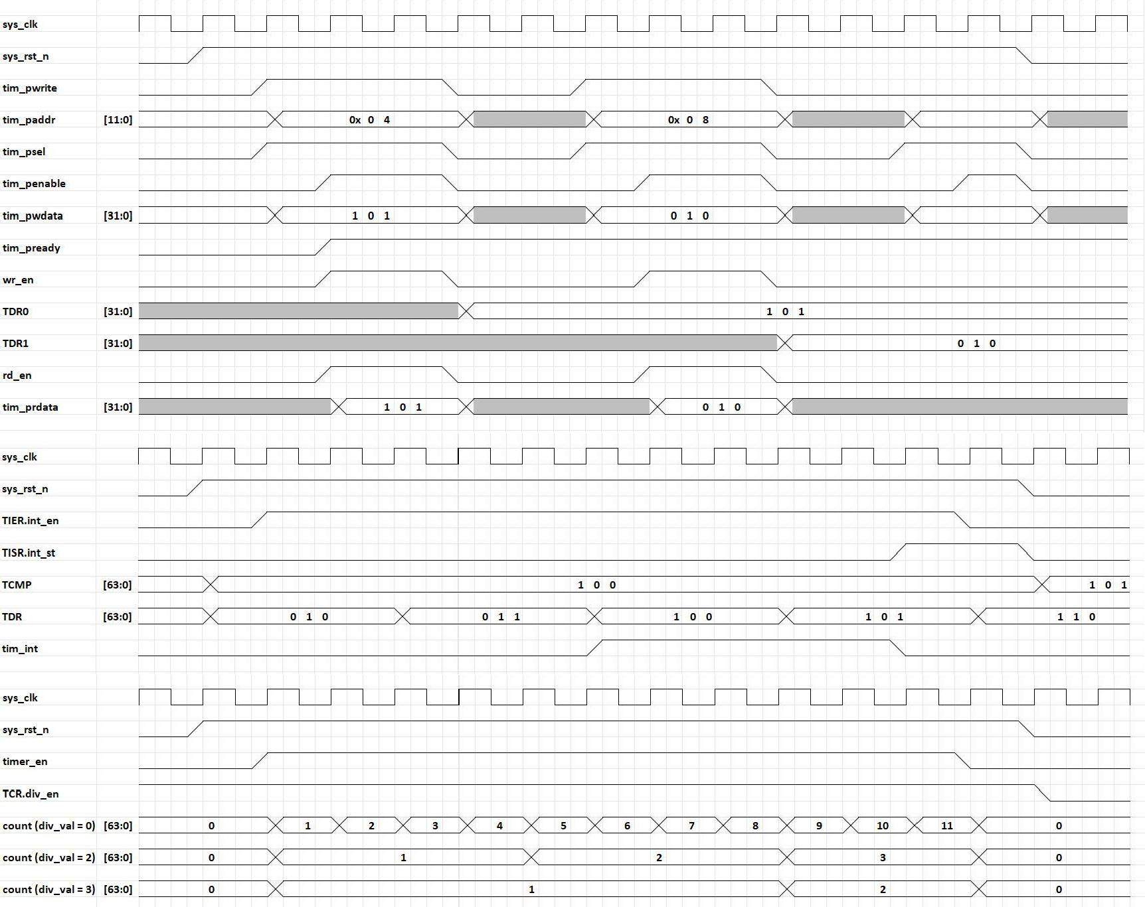

Fig 20. Sample Waveform

# 5. VPLAN

Table 15. Vplan

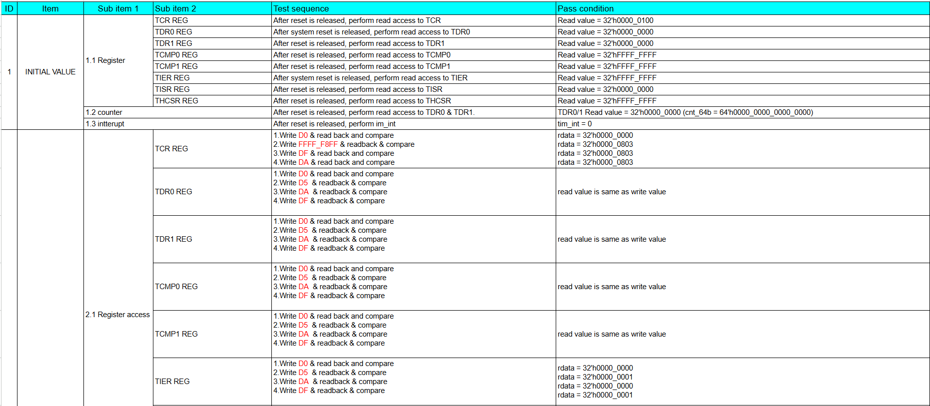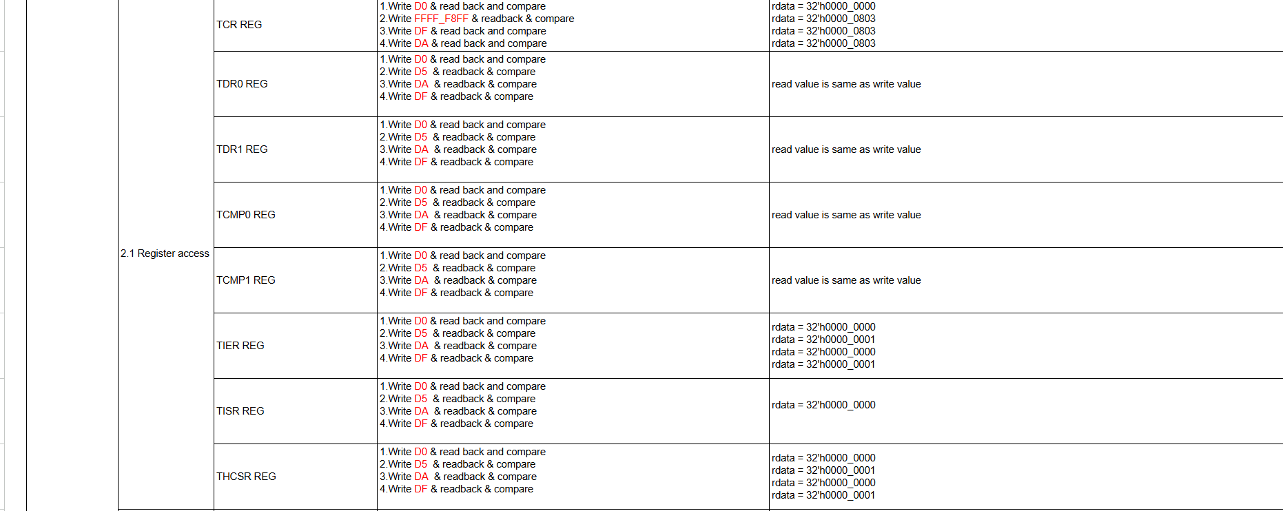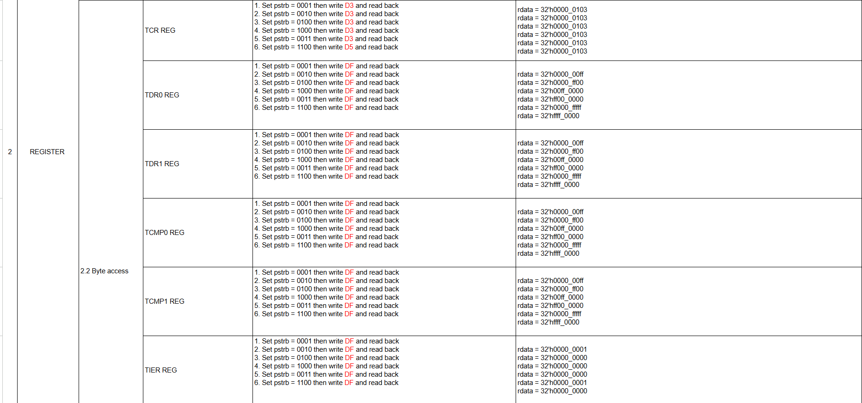

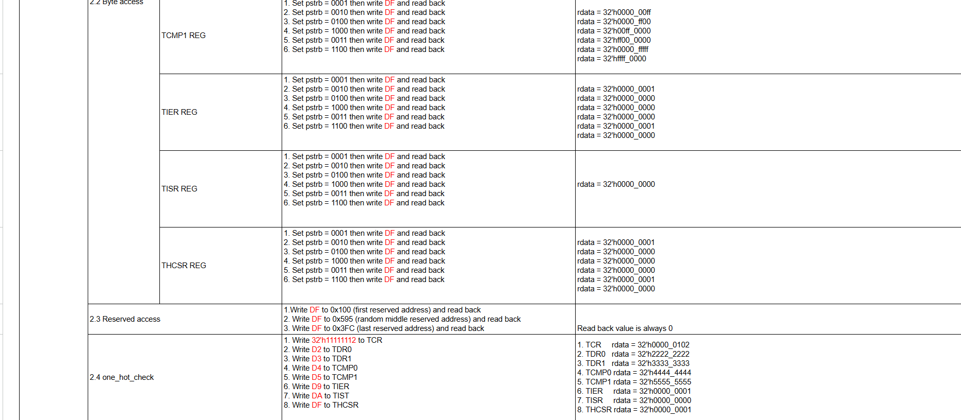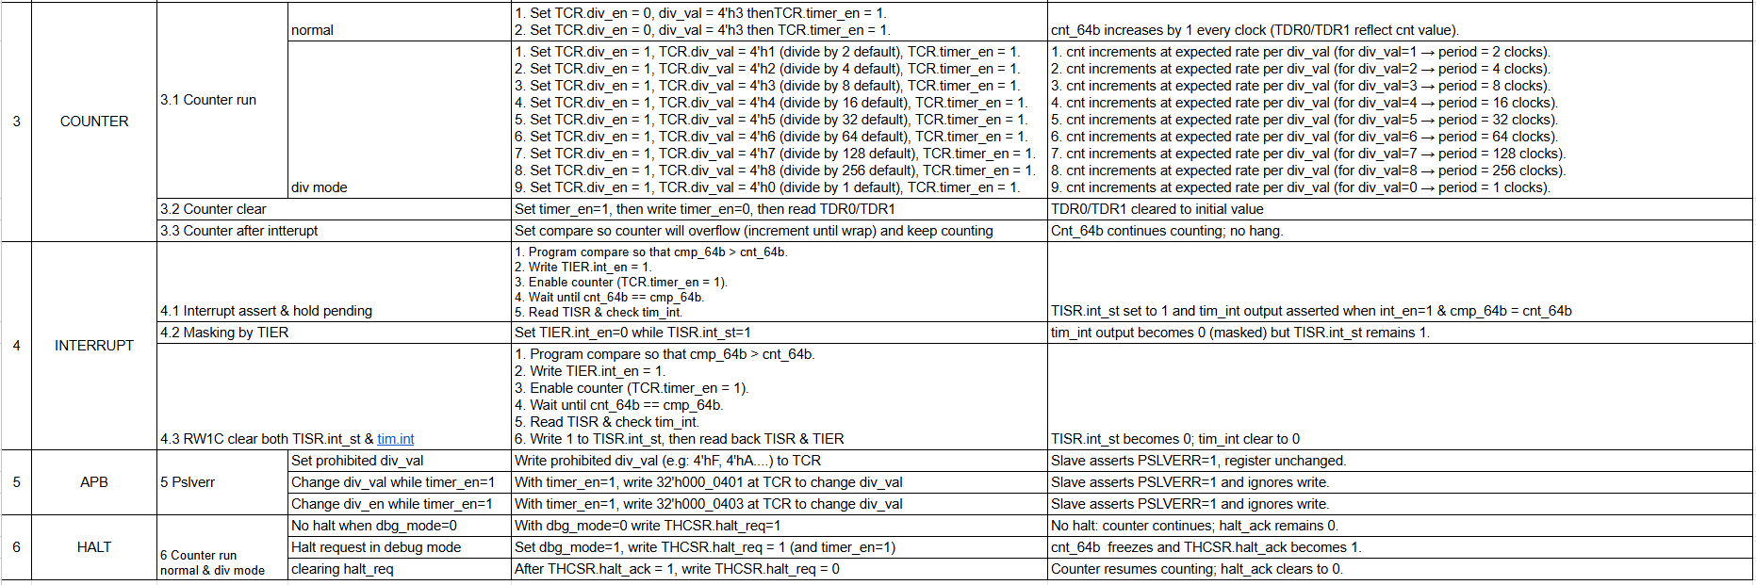

# 6. URL FILE CODE

File RTL + testbench + testcases + coverage: <https://drive.google.com/drive/folders/1UxvluI8XcAPy9teDnGtUBw6CFXaZmL5v?usp=sharing>

## RTL CODE

*apb_reg_cnt.v*

*cnt_ctrl.v*

*interrupt.v*

*timer_top.v*

## TESTCASE

*1_initial_value.v*

*21_register_access.v*

*22_register_byte_acces*

*23_register_reserved_access.v*

*24_register_one_hot.v*

*31_counter_run.v*

*32_counter_clear.v*

*33_counter_after_interrupt.v*

*4_interrupt_check.v*

*5_apb_pslverr.v*

*6_halt.v*

# 7. RESULT

## RESULT WITH TESTBENCH + TESTCASES

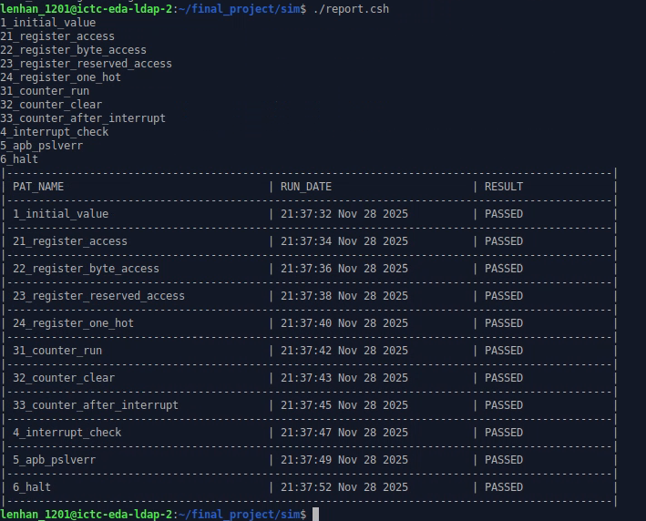

Fig 21. Testcase Report

## RESULT WITH GOLDEN MODEL

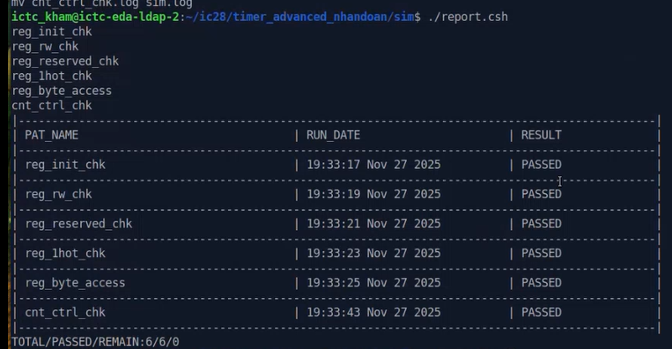

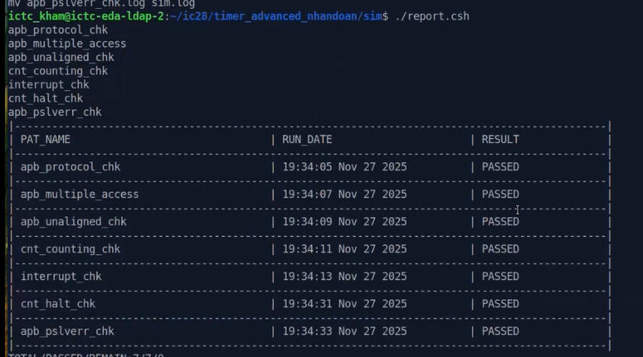

Fig 22. Golden Model Report

## COVERAGE

BEFORE EXCLUDE:

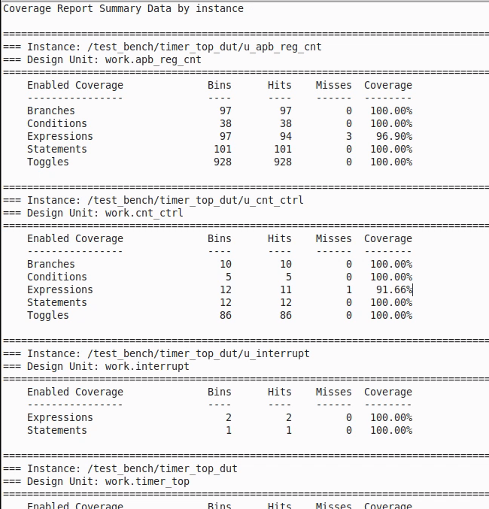

Fig.23 Sumary coverage report

Testbench never have 100% coverage because :

* + 1. wr_en & rd_en never asserts when PSEL=0 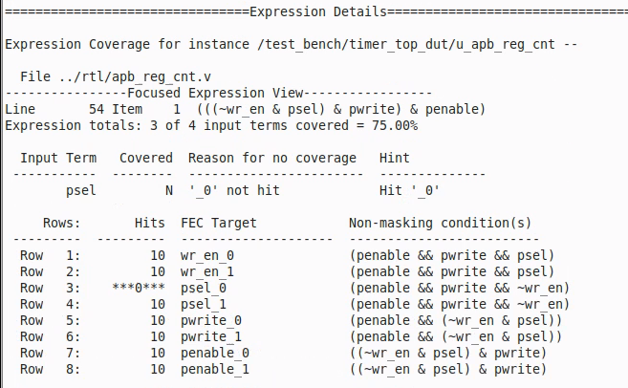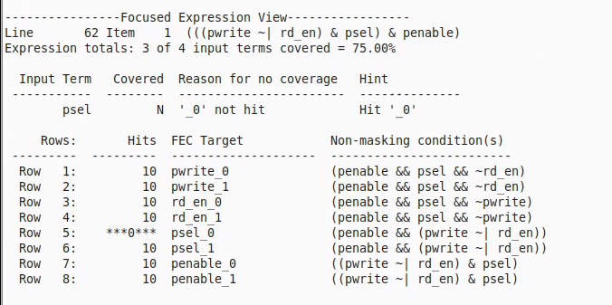
    2. *This pwdata[11:8] is not div_val: this is just an condition of TCR register to prevent write data*

Row 5 corresponds to the input term (**pwdata[11:8] < 9 ) = FALSE**, meaning the condition pwdata < 9 is evaluated and is FALSE.  
However, in the RTL expression ((pwdata > 8) | ((pwdata < 9) && timer_en)), whenever pwdata ≥ 9, the left operand (pwdata > 8) becomes TRUE, and the OR operator short-circuits the right operand. As a result, the condition (pwdata < 9) is never evaluated for the FALSE case.

When pwdata < 9, the condition is always TRUE.  
When pwdata ≥ 9, the condition is not evaluated.

Therefore, the term (pwdata < 9)_0 is **unreachable** and Row 5 naturally has 0 hits.

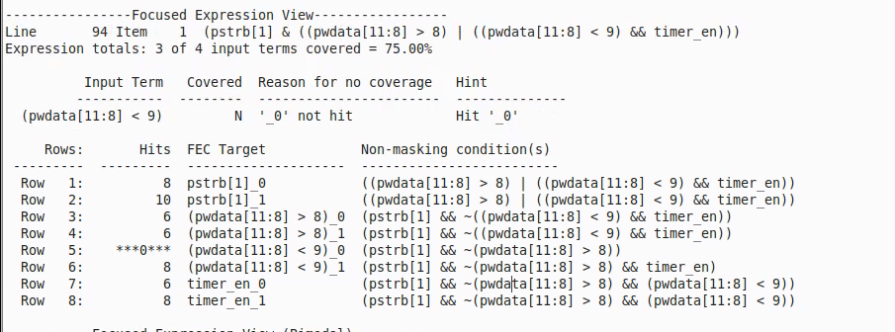

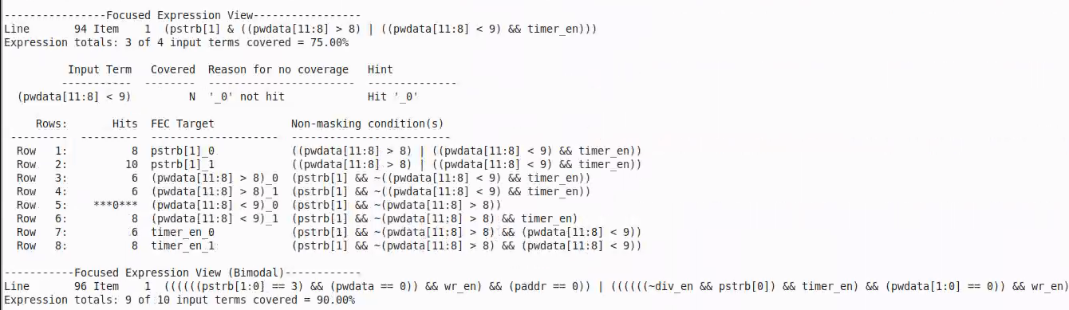

* + 1. The FALSE case of the condition (div_val != 0) is unreachable in this expression.  
       The term belongs to the third OR-branch: ((timer_en && div_en) && (div_val != 0) && pulse).

For the expression to evaluate this term in the FALSE case, all of the following must hold simultaneously:

• timer_en = 1  
• div_en = 1  
• pulse = 1  
• div_val == 0

However, pulse is only generated when div_val != 0.  
Therefore, when div_val = 0, the gating condition for this expression never becomes TRUE, and the RTL never evaluates (div_val != 0) in the FALSE path.

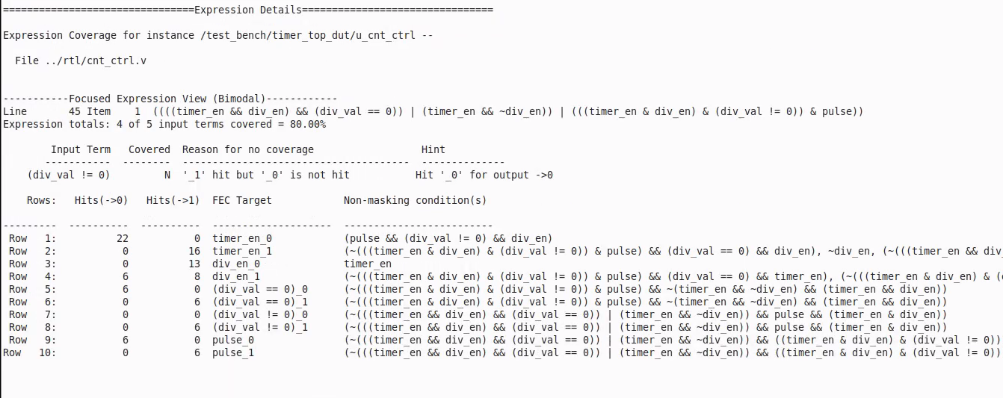

AFTER EXCLUDE:

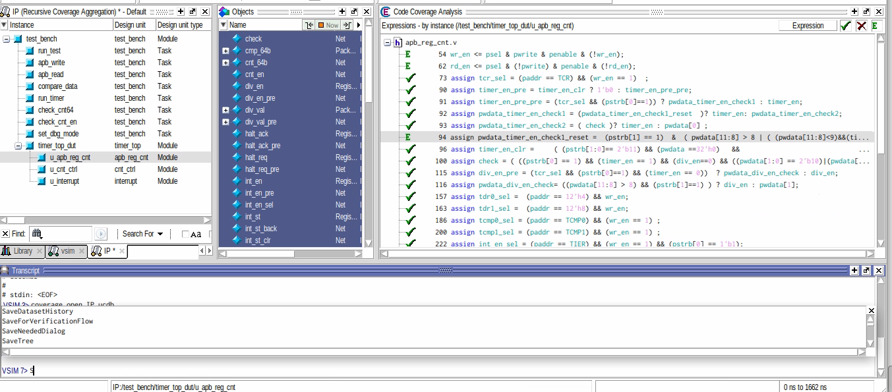

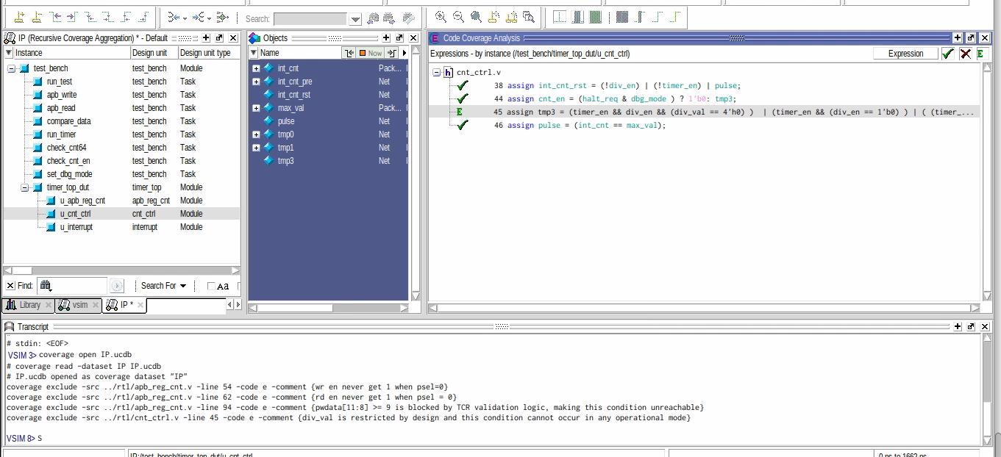

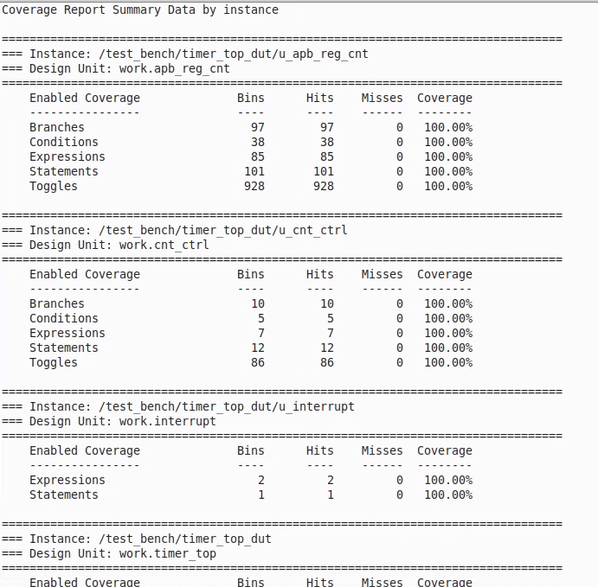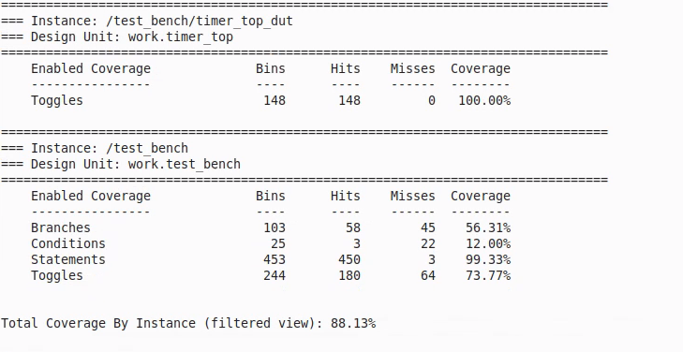

Fig 24. Summary report - Coverage after exclude

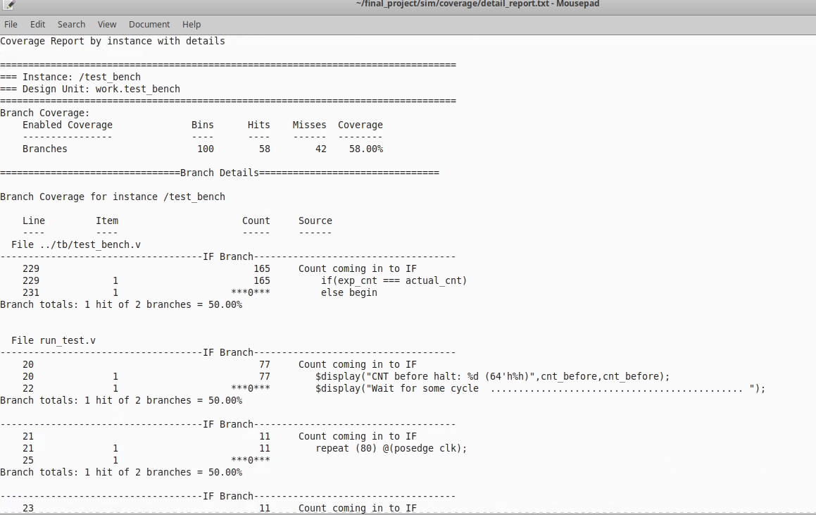

Fig 25. Detail report - Coverage after exclude